센티넬원 리포트

# 기간 : 2023-08-17 ~ 2023-11-17

# scope : Wonik>0-머트리얼즈>Default Group

## 1. OS별 엔드포인트

|  |  |
| --- | --- |
| **OS 유형** | **엔드포인트 수량** |
| windows | 684 |
| linux | 1 |

## 2. 버전별 엔드포인트

|  |  |
| --- | --- |
| **에이전트 버전** | **엔드포인트 수량** |
| 22.3.5.887 | 492 |
| 22.2.4.558 | 47 |
| 22.3.4.612 | 20 |
| 4.6.12.241 | 2 |
| 4.0.3.53 | 13 |
| 21.7.5.1080 | 94 |
| 22.1.4.10010 | 15 |
| 22.1.2.217 | 1 |
| 22.1.2.7 | 1 |

## 3. 보호되고 있는 엔드포인트

|  |  |
| --- | --- |
| **감염여부** | **엔드포인트 수량** |
| Healthy | 663 |
| Infected | 22 |

## 4. 기간내 Top20 탐지 Endpoints

|  |  |  |
| --- | --- | --- |
| **No.** | **Endpoint** | **탐지건수** |
| 1 | C3H6분석 | 15 |
| 2 | 2210104WBA00687 | 12 |
| 3 | 2200701WBA00631 | 10 |
| 4 | DESKTOP-SA9VJNH | 7 |
| 5 | 2200103WBB00464 | 7 |
| 6 | DESKTOP-VC1OEU0 | 7 |
| 7 | 2180802WBA00060 | 6 |
| 8 | 2211203WBA00570 | 6 |
| 9 | DESKTOP-R4NAJEK | 6 |
| 10 | DESKTOP-3D8S9UI | 6 |
| 11 | DESKTOP-V5U3VDE | 5 |
| 12 | LIQIANKUN | 5 |
| 13 | PC-20190715CHXN | 4 |
| 14 | DESKTOP-17E4NS6 | 4 |
| 15 | DESKTOP-14G866U | 4 |
| 16 | 2170403WBA00735 | 4 |
| 17 | 2220107WBA00757 | 4 |
| 18 | DESKTOP-FL478JF | 4 |
| 19 | 2200102WBA00804 | 3 |
| 20 | 2180307WBA00902 | 3 |

## 5. 위협별 탐지

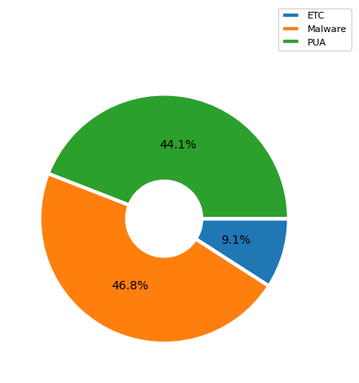

|  |  |
| --- | --- |
| **탐지내역** | **탐지수** |
| etc(Hacktool, Adware, Worm, Ransomware, Trojan, Generic.Heuristic, ) | 20 |
| Malware | 103 |
| PUA | 97 |